Posted at City Hall, 17 Hospital Drive, Eufaula, OK 74432, and at Community Center, 121 High Street, Eufaula, OK 74432 (the meeting location) on September 8, 2022, at 4:00 p.m.

CITY OF EUFAULA, OK
Community Center
121 High Street
Eufaula, OK 74432

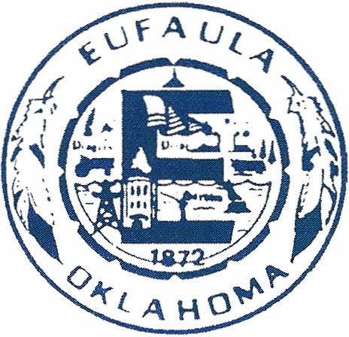

NOTICE AND AGENDA OF MEETINGS
Monday
September 12, 2022
5:30 p.m.

City Council and Eufaula Public Works Authority

The City of Eufaula encourages participation from all its citizens in public meetings. However, if participation is not possible due to a disability, notify the City Clerk in writing at least forty-eight hours prior to the scheduled meeting, and necessary accommodations will be made (ADA 28CRF/36).

Council Rules of Decorum limit citizen comments on agenda items and public hearings to five (5) minutes. Any person desiring to address the Council during such period must sign in with the City Clerk, provide their name and address, and specify the agenda item they wish to address. Remarks will be limited to the agenda item under consideration, and the speaker is allowed to speak only once. If written materials are submitted, ten (10) copies should be made available and may not be returned. Under Oklahoma law, the Council Members are prohibited from discussing or taking action on items, not on today’s agenda.

The complete packet of information for the agenda items is available online at CityofEufaulaOK.com

City Council

Mayor Todd Warren
Vice Mayor Nancy Mouser
Council Member Frank Davis
Council Member Dan Kirby
Council Member Jamie Upton

AGENDA
EUFAULA CITY COUNCIL
September 12, 2022
5:30 p.m.

- CALL TO ORDER MAYOR TODD WARREN

- INVOCATION

- PLEDGE OF ALLEGIANCE MAYOR TODD WARREN

- ROLL CALL /ATTENDANCE VALARIE COX

CONSENT AGENDA

All matters listed under the Consent Agenda are routine by the City Council and will be enacted by one motion. Therefore, there will not be a separate discussion of these items. However, if a discussion is desired, that item will be removed from the Consent Agenda and considered separately. The item will then be placed in its proper order on the regular meeting agenda and will be considered at that time.

- APPROVAL OF MINUTES.
- REGULAR COUNCIL MEETING AUGUST 1, 2022.
- SPECIAL COUNCIL MEETING AUGUST 16, 2022.

- APPROVAL OF THE TREASURER’S REPORT.

- APPROVAL OF THE AUGUST 2022 PAYROLL FIGURES FOR THE GENERAL FUND IN THE AMOUNT OF $75,783.82.

- RECEIPT OF CLAIMS: CITY OF EUFAULA.

ITEMS REMOVED FROM THE CONSENT AGENDA

- Consideration of Acceptance, Approval, Adoption, Rejection, Amendment, and/or
Postponement of an application for a Zoning Change from R1-Residential to CG-Commercial General at the following location: The West Ninety (90) feet of Lot Four (4) in Block Fifty (50) of the City of Eufaula. Commonly known as the corner lot of "F" Street and Lincoln Ave.

- Consideration of Acceptance, Approval, Adoption, Rejection, Amendment, and/or Postponement of an application for a Zoning Change from R1-Residnetial to CG -Commercial General at the following location: The East Fifty (50) feet of Lot Four (4) in Block Fifty (50) of the City of Eufaula. Commonly known as 307 E. Lincoln Ave.

- Consideration of Acceptance, Approval, Adoption, Rejection, Amendment, and/or Postponement of the Airport Taxiway Project Closeout and Final Payment.

- Consideration of Acceptance, Approval, Adoption, Rejection, Amendment, and/or Postponement of the Mayors signature on:

  - FY2023 REAP Grant Resolution
  - FY2023 REAP Grant Application
  - FY2023 REAP Grant Statement of Understanding and Assurances

- Consideration of Acceptance, Approval, Adoption, Rejection, Amendment, and/or Postponement to award the Eufaula Rodeo Arena Lease.

- REMARKS AND INQUIRIES BY CITY COUNCIL.

- ANNOUNCEMENTS.

- ADJOURNMENT.

AGENDA
EUFAULA PUBLIC WORKS AUTHORITY
September 12, 2022
5:30 p.m.

CONSENT AGENDA

All matters listed under the Consent Agenda are routine by the Public Works Authority and will be enacted by one motion. Therefore, there will not be a separate discussion of these items. However, if a discussion is desired, that item will be removed from the Consent Agenda and considered separately. The item will then be placed in its proper order on the regular meeting agenda and will be considered at that time.

- ROLL CALL /ATTENDANCE

2. APPROVAL OF MINUTES.
- REGULAR MEETING AUGUST 1, 2022.

- APPROVAL OF THE AUGUST 2022 PAYROLL FIGURES FOR THE EUFAULA PUBLIC WORKS AUTHORITY IN THE AMOUNT OF $44,424.15.

- RECEIPT OF CLAIMS: EUFAULA PUBLIC WORKS AUTHORITY.

ITEMS REMOVED FROM THE CONSENT AGENDA

- Consideration of Acceptance, Approval, Adoption, Rejection, Amendment, and/or Postponement to of pay application #24 from Lone Hickory Cattle L.L.C. in the amount of $148,010.00.

- Consideration of Acceptance, Approval, Adoption, Rejection, Amendment, and/or Postponement of Change Order #2 Water Distribution Package B – Reconciliation of Quantities.

- Adjournment.

